Chapter 9, Solution 90.

Let 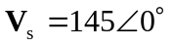, 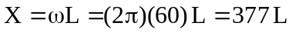
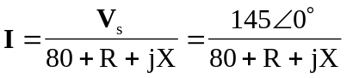

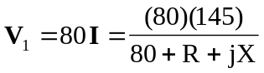
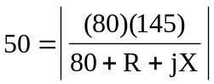 (1)

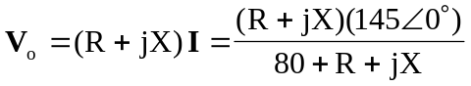
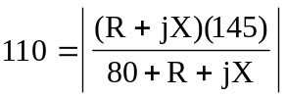 (2)

From (1) and (2),
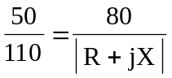
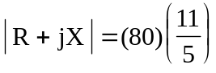
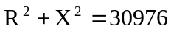 (3)

From (1),
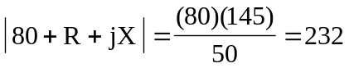
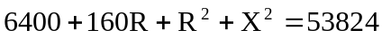
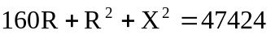 (4)

Subtracting (3) from (4),
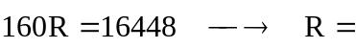 102.8 

From (3),
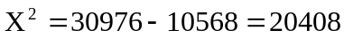
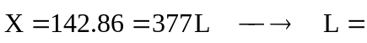 378.9 mH

